Project Design Phase-II
Technology Stack (Architecture & Stack)

Date | 3 October 2026
Team ID | SWTID-2026-6064
Project Name | Streamlining IT Procurement: Automating Standard Laptop Orders with Flow Designer
Maximum Marks | 4 Marks

Technical Architecture:
The Deliverable shall include the architectural diagram as below and the information as per the table1 & table 2
Example: Order processing during pandemics for offline mode
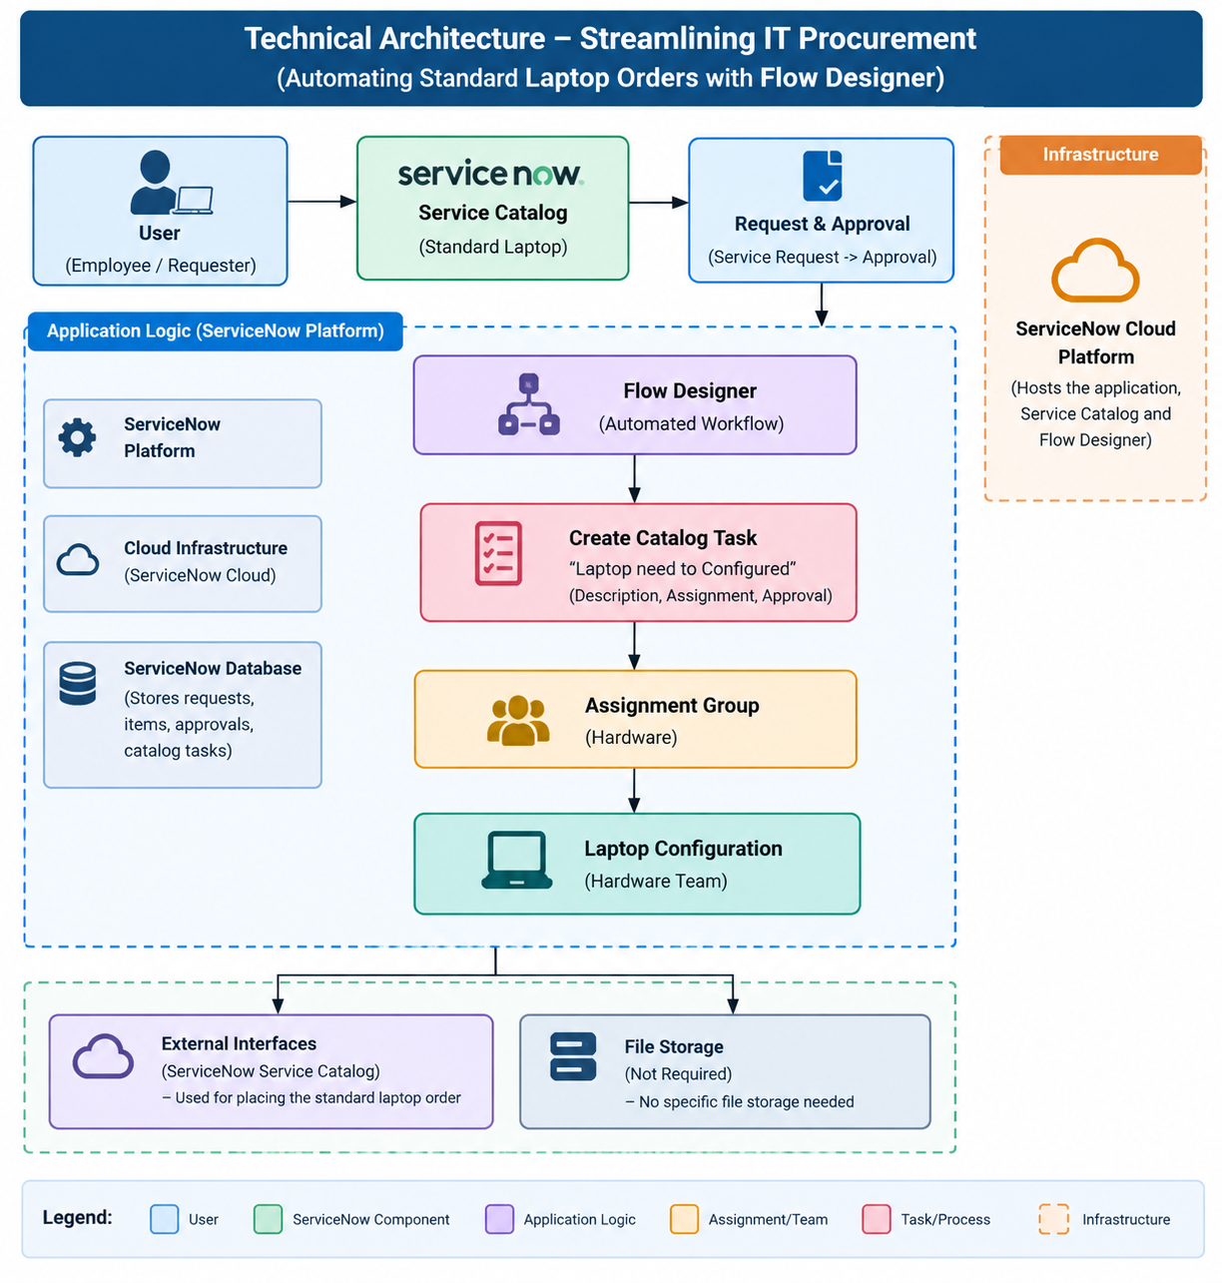
Table-1 : Components & Technologies:
S.No | Component | Description | Technology
1 | User Interface | Interface through which users request a standard laptop and place an order. | ServiceNow Service Catalog
2 | Application Logic-1 | Handles the standard laptop request and approval process. | ServiceNow Service Catalog
3 | Application Logic-2 | Automatically creates a catalog task after the request is approved. | ServiceNow Flow Designer
4 | Application Logic-3 | Updates the task details and assigns it to the Hardware team for configuration. | ServiceNow Flow Designer
5 | Database | Stores service requests, requested items, approval information and catalog tasks. | ServiceNow Database
6 | Cloud Database | Database services supporting the ServiceNow cloud platform. | ServiceNow Platform Database
7 | File Storage | No specific file storage is required for the workflow. | ServiceNow Platform Storage
8 | External API-1 | No external API is required for the standard laptop procurement workflow. | Not Applicable
9 | External API-2 | No external API is required for the standard laptop procurement workflow. | Not Applicable
10 | Machine Learning Model | No machine learning model is used in this project. | Not Applicable
11 | Infrastructure (Server / Cloud) | Hosts and executes the ServiceNow application, Service Catalog and Flow Designer workflow. | ServiceNow Cloud Platform

Table-2: Application Characteristics:
S.No | Characteristics | Description | Technology
 | Open-Source Frameworks | No specific open-source framework is used. The application is implemented using ServiceNow platform capabilities. | ServiceNow Flow Designer
 | Security | User requests are processed through ServiceNow access and approval mechanisms. Laptop requests require approval before the automated catalog task is created. | ServiceNow Access Control & Approval
 | Scalable Architecture | The workflow-based architecture can handle standard laptop requests through automated task creation and assignment, reducing manual processing. | ServiceNow Flow Designer
 | Availability | The application runs on the ServiceNow platform, allowing users and IT teams to access the service workflow through the platform. | ServiceNow Cloud Platform
 | Performance | Automation reduces manual processing by automatically creating and assigning the configuration task after approval, improving processing time. | ServiceNow Flow Designer

